DIOCESE OF OXFORD, PARISH OF BEGBROKE

LOCAL CLARIFICATION OF GRAVEYARD REGULATIONS REVISED APRIL 2026
The Diocese of Oxford has created a comprehensive set of regulations which apply to our parish graveyard. Ten years after their production, we have noticed that the requests of bereaved relatives have changed and we have therefore produced this document to clarify some issues.

We recognize that the design of monuments (gravestones) and memorials for cremated remains (ledger stones) memorials is a very personal and emotional experience. We believe that it is easier for families if they understand the possibilities and constraints from the start of the process. We have therefore worked with local funeral directors to ensure that there is clarity of communication from the outset.

We wish to allow some flexibility in material choice and design, rather than creating a graveyard where every monument looks the same. At the same time, we believe that a country churchyard should have memorials that are in keeping with the styles and materials traditionally used. The following are approved for our churchyard:

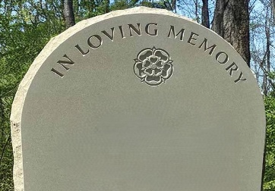 | Sandstone. There are not that many local sandstones suitable for monuments. York stone is recommended by the Diocese and is often used due to its proven durability.
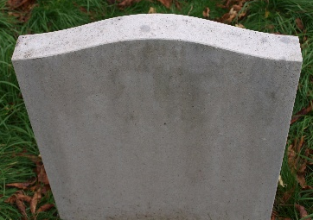 | Limestone. Hornton and Cotswold are local limestones that can make beautiful monuments. They can however suffer from erosion faster than other limestones. Portland and Purbeck, both from Dorset, are often used. Nabresina from the north of Italy is another option, similar in appearance to the two Dorset limestones.
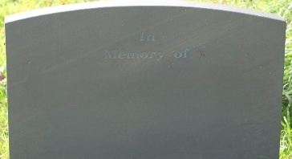 | Slate. While there are no local slate quarries, the benefits of this stone for monuments have been recognised for centuries. UK sourced slate will come from either Wales or Cumbria.
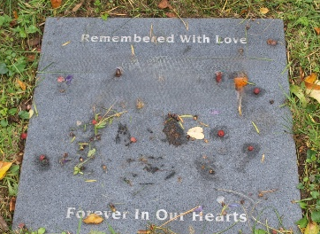 | Granite. Granite has the benefit of being long lasting but is not in keeping with the traditional style of the area. It will no longer be accepted for gravestones. It may be used for ledger stones in a light grey colour but not dark grey or black. The surface finish can be honed but cannot be polished.
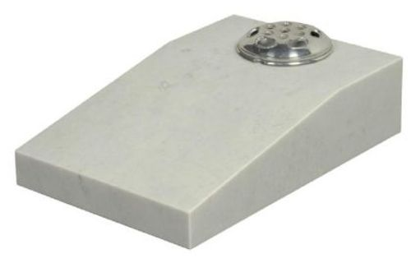 | Ledger stones and sloping desk tablets. These must be within the 460mm by 460mm (18” by 18”) maximum size of the diocesan regulations, but they may be flat or with an inclined surface and may have a flower holder incorporated in them. Maximum height is 150 mm (6”). Allowed materials are sandstone, limestone, slate and light grey honed granite as noted above

DIOCESE OF OXFORD CHURCHYARD REGULATIONS 2016

The Chancellor of the Diocese, with the advice of the Diocesan Advisory Committee, makes the following regulations:

Application, commencement and interpretation
- These Regulations apply to every churchyard which is subject to the jurisdiction of the Consistory Court of the Diocese of Oxford (but see regulation 2).
- They are subject to any regulations for a particular churchyard made or approved in writing by the Chancellor of the Diocese (whether made or approved before or after these Regulations come into operation).
- These Regulations come into operation on 1st January 2017 and replace the Churchyard Regulations for the Diocese of Oxford dated 10 June 2009.
- In these Regulations–
  - “archdeacon” means the archdeacon of the archdeaconry in which the churchyard is situated;
  - “churchyard” includes the curtilage of a church, and a burial ground of a church (whether or not it immediately adjoins the church);
  - “minister” means–
    - the incumbent or priest in charge of the benefice in which the churchyard is situated (unless a special cure of souls has been assigned to any priest for the area in which the churchyard is situated, whether in a team ministry or otherwise, in which case that priest is to be treated as the minister for the purposes of these Regulations), or
    - where there is no such person, the rural dean of the deanery in which the churchyard is situated;
  - “ledger stone” means a flat stone slab marking the place of interment of cremated remains;
  - “monument” means a headstone or similar form of commemoration;
  - “relevant regulations” means, in relation to a monument, regulations 12 to 21; and in relation to a ledger stone, regulations 22 to 28;
  - a reference to a matter being permitted or not permitted applies only for the purposes of these Regulations; it does not prevent any monument or ledger being introduced or removed under the authority of a faculty or other order issued by the Consistory Court.
- The Chancellor may, in respect of a benefice generally or of a particular churchyard, appoint a person to exercise functions under these Regulations in place of the minister; accordingly, where such a person is appointed, references to the minister are to be read as references to that person.

Authority delegated to minister
- Authority is delegated from the Chancellor of the Diocese to the minister to authorise–

  - the introduction into a churchyard of any monument or ledger stone which complies with the relevant regulations; and
  - the matters provided for in regulations 44 (addition of further inscriptions), 46 and 48 (temporary removal for addition of inscription or repair) subject to the requirements of these Regulations.
- An application to the minister for authority to introduce a monument or ledger stone must be made using the form set out in the Schedule to these Regulations.
- The minister may, in his or her discretion, decline to authorise the introduction of a monument or ledger stone or other matter provided for in these Regulations despite the fact that what is proposed complies with the provisions of these Regulations.
- The minister must decline to authorise the introduction of a monument or ledger stone or any other matter which does not comply with the provisions of these Regulations.
- The minister may, if he or she considers it expedient, refer an application for authorising a monument or ledger stone or other matter provided for in these Regulations to the archdeacon; and where the minister does so, the archdeacon may exercise the functions of the minister under these Regulations.
- Any question as to the interpretation or application of these Regulations is to be determined by the Chancellor of the Diocese.

Monuments
- Regulations 13 to 21 apply to monuments.
- A monument may be introduced only at the place where the body of the person to be commemorated by the monument is buried.
- Six months must have elapsed since the date of burial before a monument may be introduced.
- The maximum permitted height for a monument is 1220mm (48”) and the maximum permitted width is 915mm (36”).
- The maximum permitted thickness for a monument is 155mm (6”) and the minimum permitted thickness is 75mm (3”) (except for slate monuments, for which the minimum permitted thickness is 40mm (1.5”)).
- Unless the monument is to be supported by a pre-cast concrete shoe situated below the ground, the minister must be satisfied that the monument will be inserted sufficiently deeply into the ground to ensure its stability, having regard to the nature of the ground and any likely settlement.
- A monument may have a visible stone or concrete base only if–
  - the base is an integral part of the design of the monument,
  - it does not project from the monument by more than 50mm (2”) away from the place of burial and 205mm (8”) towards the place of burial, and
  - the monument is connected to the base by non-ferrous dowels.
- The base may make provision for not more than two vases that are to be fitted into it.
- Any foundation slab for a monument must not be visible after the work of introducing the monument has been completed.

- A monument must meet the requirements of regulations 29 to 45 (design, materials, inscriptions etc.).

Ledger stones
- Regulations 23 to 28 apply to ledger stones.
- A ledger stone may be introduced only at the place where the cremated remains of the person to be commemorated by the ledger stone are interred (but see regulation 25).
- Where burials in a churchyard have been discontinued by Order in Council under the Burial Act 1853 or 1855, a ledger stone may be introduced only–
  - if the interment of the cremated remains was authorised by a specific faculty, or
  - if the remains were interred in an area which has been set aside by faculty for the interment of cremated remains generally
(but see regulation 25).
- Ledger stones are not permitted where the parochial church council has adopted a policy of commemorating persons whose cremated remains are interred in the churchyard exclusively by other means (for example, wall plaques or a book of remembrance).
- The maximum permitted dimensions for a ledger stone are 460mm (18”) in length and 460mm (18”) in width.
- A ledger stone must be laid so that its upper surface is flush with the ground.
- A ledger stone must meet the requirements of regulations 29 to 45 (design, materials, inscriptions etc.).

Design
- A ledger stone must be rectangular or square (but a monument need not be).
- A monument or ledger stone must not take the form of a statue or of a particular object such as a heart, a person, animal or other figure; but a monument (though not a ledger stone) may take the form of a representation of a book.
- A monument or ledger stone must not include any lighting, whether electric or otherwise or any glass shades.
- A monument or ledger stone must not include–
  - a portrait, photograph or other image of an individual (whether of the person commemorated or any other person)
  - any other pictures or imagery except as permitted by regulation 33
  - any moulding
  - any video or sound recording
  - a QR code or other machine-readable label
  - kerbs or other fencing, railings or other demarcation
  - stone or glass chippings

- A black, white or uncoloured etching or carving may be permitted provided that it–
  - is reverent and not indicative of beliefs contrary to the doctrine of the Church of England,
  - does not depict an individual, and
  - covers no more than one-fifth of the surface of the monument or ledger stone.
- A monument may be inscribed with a stonemason’s mark provided that the mark is not in a prominent position.

Materials
- A monument or ledger stone must be made of natural stone or of hardwood.
- The surface of the stone must not be made reflective by being polished or finely honed.
- A monument or ledger stone is not permitted if it–
  - is black, blue, red or green (or appears to be any of those colours) or is otherwise brightly coloured,
  - is made of marble, synthetic stone or plastic, or
  - is painted.

Inscriptions
- A monument or ledger stone may include an inscription provided it is simple, reverent and not contrary to the doctrine of the Church of England.
- An inscription may include quotations from the Bible or from literary sources (subject to regulation 38).
- In addition to the formal names of the person commemorated, nicknames or other names by which the person was familiarly known may be included as part of the person’s name, within brackets or inverted commas (subject to regulation 38).
- An inscription must be incised or in relief and may be uncoloured, grey or black only; plastic, lead or other inserted lettering is not permitted.
- Hand-crafted letter cutting is permitted.
- Cursive script (that is, a script which gives the appearance of having been written in a running hand) is not permitted.
- The addition of further inscriptions which comply with regulations 38-43 and which are consistent with the style and language of the original inscription may be authorised by the minister following further burial in a grave or interment of further cremated remains.
- An application for authority to add a further inscription must be made to the minister in writing and provide details of the proposed additional inscription (including the style of lettering to be used and the place on the monument or ledger stone where it is proposed to be added).

Works to existing monuments etc.
- The owner of a monument or ledger stone which is less than 50 years old may carry out works of repair to it (including renewing lettering) without a faculty provided that the monument was

lawfully introduced into the churchyard and the minister authorises the repairs before they are carried out.
- Repairs which would result in the monument or ledger stone ceasing to comply with these Regulations must not be authorised.
- The owner of a monument or ledger stone which is less than 50 years old may, if authorised to do so by the minister, remove it from the churchyard for not more than 3 months for the purpose of adding an inscription authorised under regulation 44 or carrying out repairs authorised under regulation 46.
- A monument or ledger stone which is more than 50 years old must not be removed from the churchyard without the authority of a faculty.

Miscellaneous
- Individual gardens, including the planting of shrubs are not permitted; but the minister may authorise the planting of a small number of bulbs.
- Plastic flowers and plastic wreaths are not permitted.
- Cut flowers and silk flowers may be left at the place of burial or interment of cremated remains but must be removed once they are decaying or have become faded.
- With the permission of the minister, up to 3 toys or similar objects may be left at the place of burial or interment of cremated remains for a period of 12 months from the date of burial or interment but must be removed at the end of that period.
- The minister, or a person acting on his or her behalf, may remove any objects which are not, or have ceased to be, authorised under these regulations and which have not been authorised by faculty.

DIOCESE OF OXFORD

APPLICATION TO MINISTER FOR INTRODUCTION OF MONUMENT OR LEDGER STONE IN CHURCHYARD
This application may be made by the legal personal representative or an executor (usually, but not always, a close relative) of the deceased

Parish of Archdeaconry of
Plot Number (on attached plan)

Name of applicant:

Address, telephone number and email address of applicant:
…………………………………………………………………………………………………………
…………………………………………………………………………………………………………
………………………………………………………………………………………………………....
- I make this application for authorisation to introduce a monument ledger stone in the churchyard of the above parish.
- I am the state relationship to the deceased of name of deceased and/or the administrator/executor or state any other legal authority of his/her estate. The deceased lived at address.
- I acknowledge that I have been given a copy of the Churchyard Regulations 2016 (“the Regulations”) and understand them.
- I understand that–
  - the only monument or ledger stone that may be introduced if this application is granted is one that–
    - falls entirely within the Regulations, and
    - is as described in the attached Schedule;
  - the authorisation that is given to me to in the first instance only permits the monument or ledger stone to remain in the churchyard for a period of 100 years and that this period of time may be shortened, or extended, by a faculty granted the Consistory Court of the Diocese of Oxford (“the Court”);
  - a breach of the Regulations (now or at some future time) or a failure to maintain the monument or ledger stone may result in its being removed by the church authorities
  - neither I nor anyone else is permitted to remove the monument or ledger stone unless the minister authorises its temporary removal under regulation 48 of the Regulations or I am granted a faculty by the Court authorising me to do so;
  - the Court has sole jurisdiction in interpreting and applying these arrangements.

Signed Date Applicant

This page is for the use of the minister only and should be left blank by the applicant

MINISTER’S DECISION ON APPLICATION

I, name of minister being state office held

*Grant your application dated
and in exercise of the authority delegated to me authorise you to introduce a monument ledger stone which conforms with the details set out in the Schedule to the application.
This authorisation permits the memorial to remain within the churchyard for a period no longer than 100 years from the date of this decision.

*Refuse your application dated
because insert summary reasons

Signed Date Minister

*Delete as applicable

Schedule
The applicant must insert below an accurate description of the proposed monument or ledger stone. The description must include details of its size, design, materials, finish and inscription (including the style of lettering to be used).
The applicant must also provide–
- a sketch, plan or marked-up photograph of the churchyard showing the position of the plot, and
- a sketch of the design of the proposed monument or ledger stone.
In the case of a monument, the applicant must provide details of the depth to which the monument will be inserted into the ground to ensure its stability (unless it is to be supported by a pre-cast concrete shoe situated below the ground).

